## Adding a coupling transformer

The TX coil impedance will vary over a 1:400 range over the nominal 50 kHz - 20 MHz operating range. At most frequencies, the impedance is so low that the signal generator (nominal 50 ohm output impedance) is unable to generate much current. An impedance matching transformer is used to improve the situation. The actual turns ratio is a trade-off between maximizing the TX power at low frequencies vs. maximizing the TX power at high frequencies.

The final design uses a Amidon FT-114-61 toroidal core (114 reflects the diameter, 61 is the material) <http://www.amidoncorp.com/ferrite-toroids/> . The turns ratio is 70:14. The center is quite full because plastic insulated wire was used rather than enameled, in an effort to reduce inter-winding capacitance. The shield of the TX wire is carried across the coil and connected to the BNC ground.

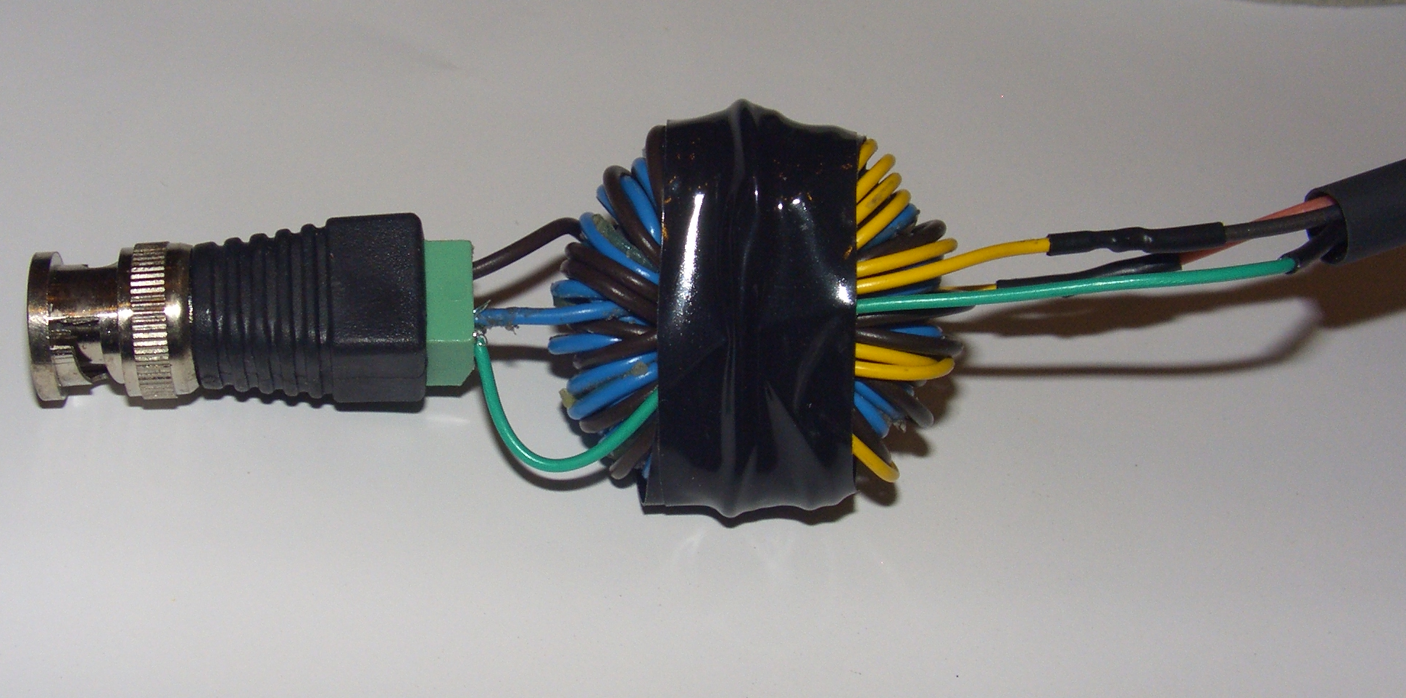

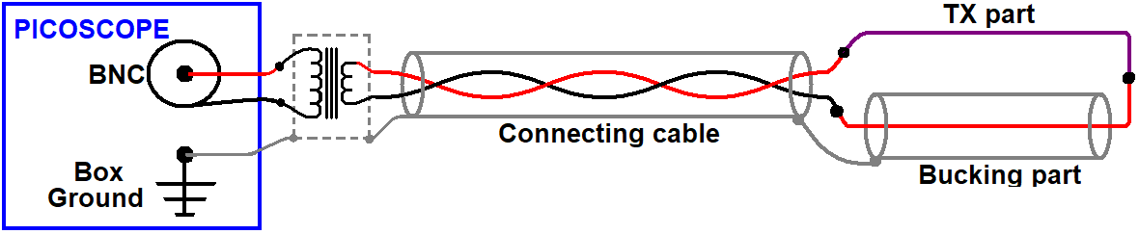

Amidon makes another material, type 67, with a higher initial permeability, which might also work here. This would allow the number of turns to be scaled back, and possibly a smaller core, by this needs testing.